**MATHEMATICS METHODS UNIT 1 TEST 3**

**CALCULATOR ASSUMED NAME: ___________________________**

**TIME ALLOWED: 40 MINUTES**

***Show all your working clearly.*** *Your working should be in sufficient detail to allow your answers to be checked readily and for marks to be awarded for reasoning. Incorrect answers given without supporting reasoning cannot be allocated any marks. For any question or part question worth more than two marks, valid working or justification is required to receive full marks. If you repeat any question, ensure that you cancel the answer you do not wish to have marked.*

**QUESTION 5 [8 marks: 1, 1, 2, 2, 2]**

To qualify as an umpire, candidates had to pass both a written test and a practical test. Data from previous tests indicated that 90% of candidates passed the written test and of these 70% passed the practical test. Of those who failed the written test, 40% also failed the practical test.

(a) Represent this information on a tree diagram below.

(b) What percentage of candidates passed both tests?

(c) What percentage of candidates passed at least one test?

(d) Of those who did not qualify as an umpire what fraction of the candidates failed the written test?

(e) Are the events ‘Pass the written test’ and ‘Pass the practical test’ independent? Justify your answer.

**QUESTION 6 [3 marks: 1, 2]**

A test containing five questions was given to a group of students.The table below shows the probability of the number of questions (out of 5) being answered correctly.

|  |  |  |  |  |  |  |
| --- | --- | --- | --- | --- | --- | --- |
| Number of questions answered correctly () | 0 | 1 | 2 | 3 | 4 | 5 |
| Probability that this number of questions were answered correctly | *x* | 0.05 | 0.16 | 0.44 | 0.23 | 0.07 |

(a) Determine *x*

(b) Evaluate $P\left(3≤n≤4 \right| n>2)$

**QUESTION 7 [7 marks: 2, 2, 3]**

Given that sin P =and cos Q = , where P and Q are each obtuse angles, find the exact value of:

(a) cos P

(b) sin Q

(c) sin(P-Q)

**QUESTION 8 [7 marks: 4, 3]**

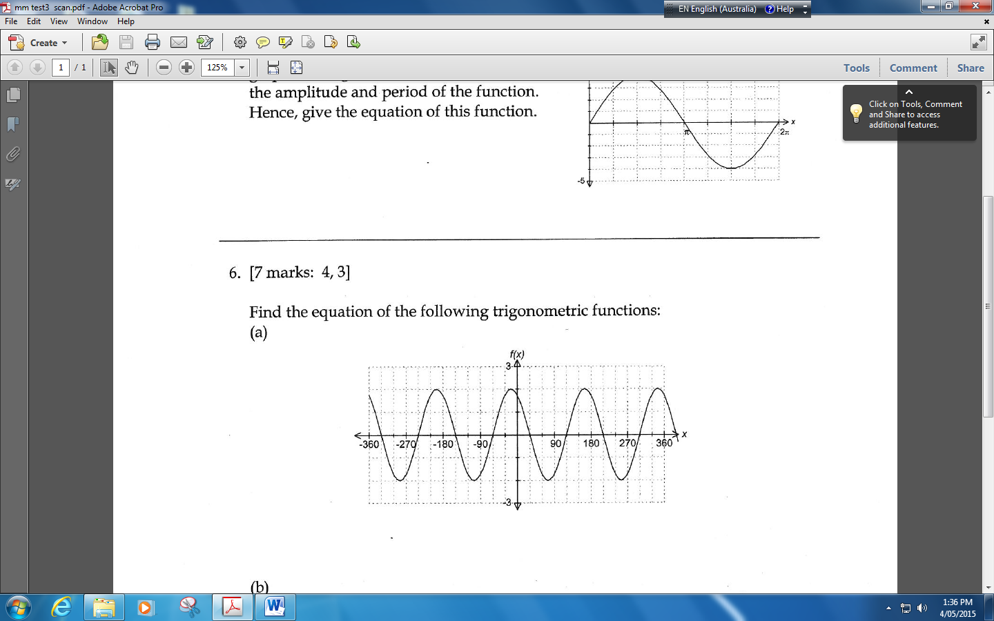 (a) If the graphed function below has the equation of form $f\left(x\right)=acos⁡(bx-c)$, determine the values of *a*, *b*, and *c*. (4 marks)

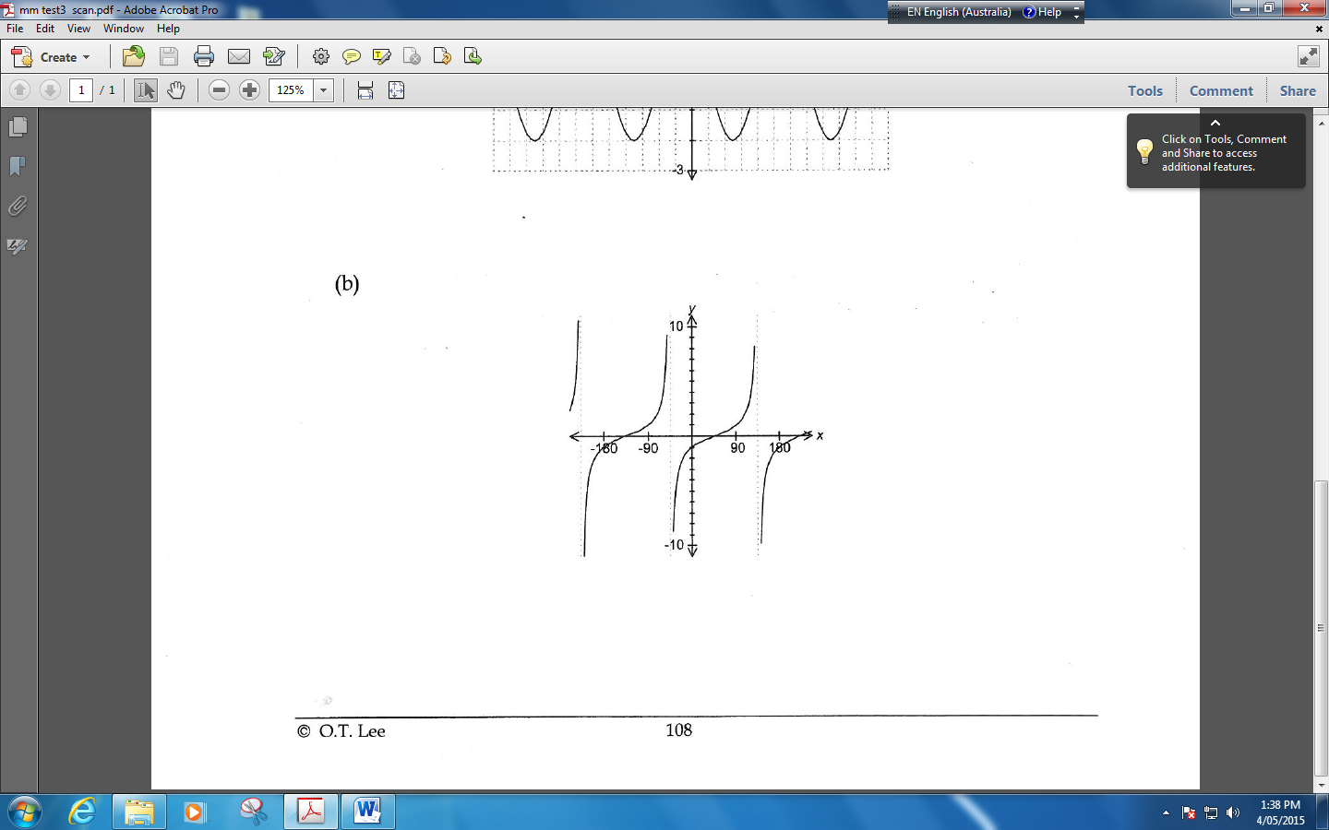 (b) If the graphed function below has the equation of form $f\left(x\right)=tan⁡(bx+c)$ determine the values of $b$ and $c$.

**QUESTION 9 [6 marks: 3, 3]**

For two events $M$ and $K$, $P\left(M\right)=0.4$ and $P\left(M \right|M∪K)=0.8$

Determine $P(K)$ if

(a) events $M$ and $K$ are mutually exclusive.

(b) events $M$ and $K$ are independent.

**QUESTION 10 [8 marks: 4, 4]**

Use an appropriate trigonometric identity to find the exact value of:

(a) sin 75°

(b) $\tan{(})$

**TOTAL MARKS 39**

<http://wace1516.scsa.wa.edu.au/mathematics/> (accessed 1st May 2015)

O T Lee.,2014. WACE Revision Series, Mathematics Methods, ATAR Course, Year 11 Units 1 and 2, Singapore, Academic Task Force